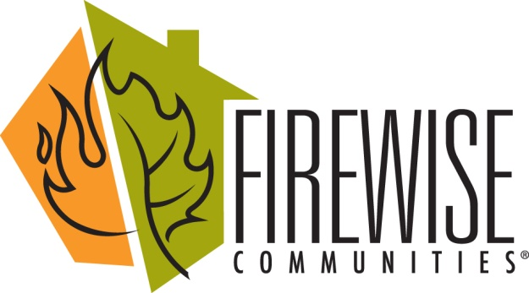
FireWise Bulletin
February, 2018

Although it’s hard to think of wildfires and mitigation tasks when there are several inches of snow on the ground, there are numerous tasks you can either complete despite the snow piles or at least plan for another day in the near future. Some projects recommended by the National Fire Protection Agency (NAFP) to make your home more resistant to a fire:
>Rake and remove pine needles and dry leaves within a minimum of 5 feet of your home’s foundation. Thirty feet is optimal.
>Get out your measuring tape and see how close wood piles are located to the home. If closer than 30 feet, they need to be relocated.
>Sweep porches and decks, clearing them of leaves and pine needles. Rake under decks, porches, sheds.
>Remove items stored under decks and porches and relocate them to a storage shed, garage, or basement.
>Collect downed tree limbs and broken branches and stack them away from under trees and any structure. Have them chipped on our next Chipping Day.
>Join forces with neighbors and pool your resources to mitigate your adjoining properties.
>Arrange now for mitigation of zones one and two (up to 100 feet out from your house). Apply for the 50/50 grant for work that must be completed by the end of June.

The chipping rebate will once again be offered this year. Many funds have been slashed from our usual sources of grants, but the chipping rebate has managed to survive.

Welcome packets for new home/property owners are now available from your FireWise Ambassadors. If you know of a new member to our community, please contact Peggy Beach or the Myatts so that we might get a packet to them.

It’s time to review and revise our Community Wildfire Protection Plan (CWPP). If you would be interested in helping with that committee or have ideas you would like to suggest, please contact Peggy or Al or Jo.

Peggy Beach, 264-0463, peggybeach9@aol.com
Al and Jo Myatt, 264-1125, themyatts.co@gmail.com

